Geography Homework
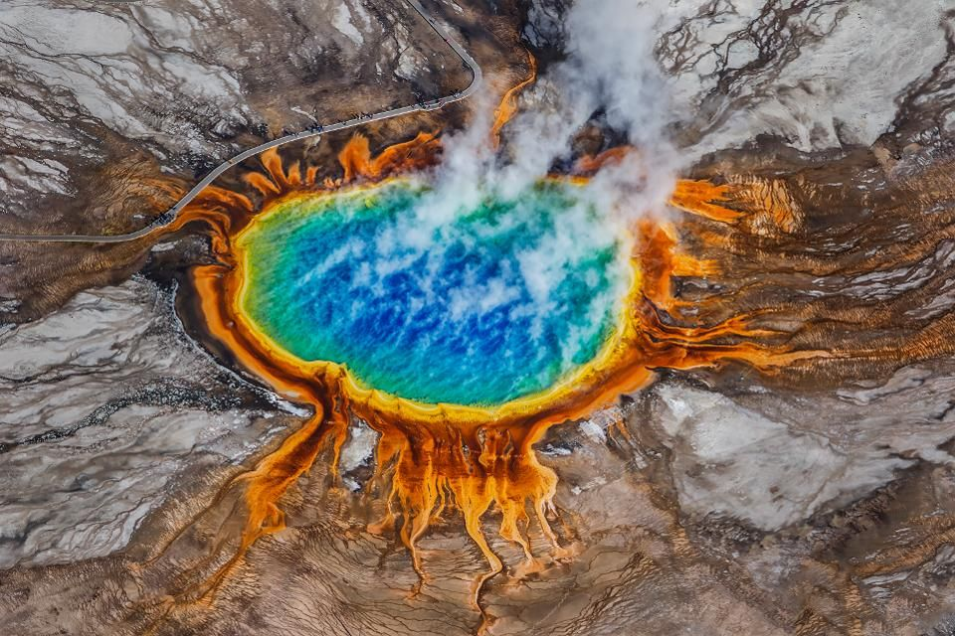

Your task this week is to research and write a report about the Yellowstone super volcano. In Geography we have looked at Volcanoes, how they are formed and the dangers they pose. We have also looked at North America which is where Yellowstone super volcano is located.
Your report must include:
- Where is the Volcano?
- How old is it?
- Has it erupted before?
- Compare it to Mount Vesuvius (We looked at this volcano in Geography in August term)
- What dangers could we face from this volcano?
- Do we face any danger from the volcano here in the UK?


