Steve Jobs

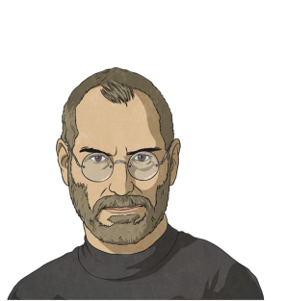
Steven Paul Jobs was an American businessman who helped create one of the most recognisable and famous companies in the world. Along with his friend and business partner, he changed the face of technology by selling millions of smartphones and tablets to people all over the world. Early Life Steve was born in 1955, in San Francisco, California, and was brought up by his adoptive parents. His father was good at making things which had a big impact on Steve. He loved how his father could seemingly build anything and that inspired him to build things himself. Steve developed a love for mechanics and his father set up a workbench in their garage. By the age of ten, Steve began working with electronic devices and spent most of his time exploring how things worked.

Although Steve was very clever and fantastic at what he did, he sometimes found life hard at school. He didn’t have that many friends. Over the years, as Steve progressed through school, he spent a lot of his time alone and was often bullied. Despite this, he kept up his interests in electronics and, after going to college, decided to do something completely different. In 1974, at the age of 19, Steve travelled through India where he studied Zen Buddhism, which helped him focus on his life more clearly.
Building His Business
In 1976, having returned to the USA, Steve met up with his friend, who had invented a special type of computer. Steve thought it was brilliant and they started up a company. They came up with an interesting name for the computer and began making more of them. At first, they had to do business out of Steve’s garage as they didn’t have anywhere else to go. Steve’s friend focused on the electronics while Steve began working on the computer’s design. Over the next few years, they sold many computers and became a well-known brand.

Tablets and Smartphones By 1985, the company had become really popular. It had its own buildings and employed hundreds of staff. Despite this, Steve decided to leave. He created his own company which did very well and he also became involved in award-winning animated films. However, in 1997, his new company was bought by his old company for $427 million! It had taken 12 years, but Steve Jobs was back at the place he had started!

The company was soon familiar to people all over the world. It began making portable music players, software, tablets and smartphones which were all huge hits. There have been many versions of the smartphone and lots of people buy the latest models whenever they come out. This made Steve Jobs one of the richest and most famous men in the world. His ground breaking impact on modern technology and everyday life will never be forgotten.

Glossary
Electronic devices: Things that produce or are powered by electricity, such as a smartphone, tablet or computer.
Electronics: The science of designing electrical circuits.
Mechanics: The machinery or working parts of something.
Portable: Easily carried or moved. Zen Buddhism: A way of thinking deeply.

- Along with his business partner, Steve Jobs created… Tick two.
Tablets
Televisions
Radios
Smartphones

- According to the text, find and copy two things Steve had an interest in when he was younger.

- How did these interests help Steve when he was older?

- In what way do you think his father helped influence Steve’s success in later life?

- What did Steve do that was ‘completely different’?

- What made Steve 'one of the richest and most famous men in the world'?

- Join the date to the correct event:
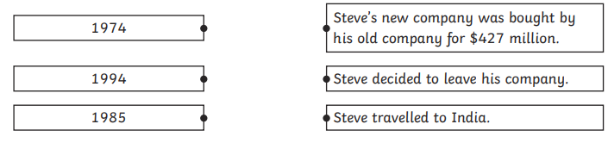

Homework:
- Create a timeline on all his inventions use images to provide detail of all his products.
- What is your favourite Apple product? Explain why.

