David Walliams
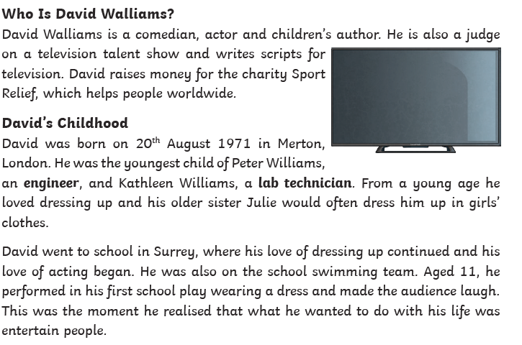
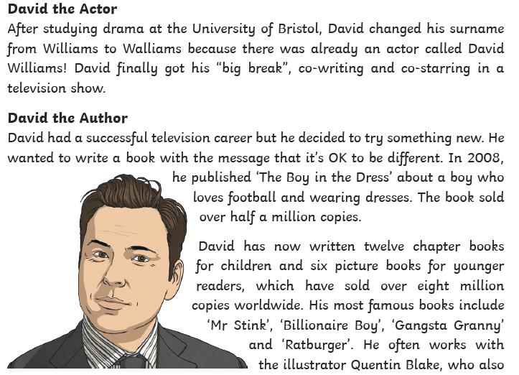

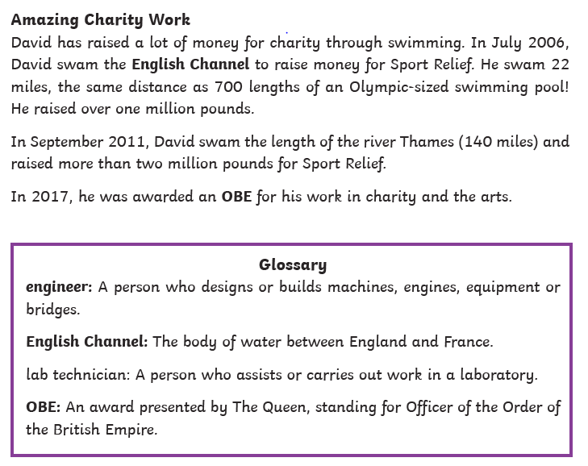
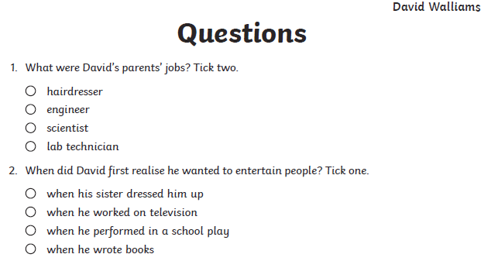



Futures Week Year 4- Steve Jobs

Steve Jobs, the chief founder of Apple Computer grew up with a strong interest in electronics. The entire life of Jobs is an epitome to his belief that it is only through great work that one can lead a truly satisfying life.

Task:
Research on and write Steve Jobs’ biography. Don’t forget to include his many contributions to technology and our day-to-day lives.

