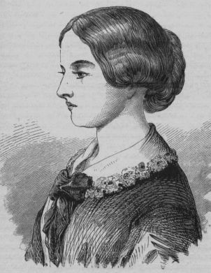
Inspirational nurses

Florence was born in Italy and named after the city of her birth. But her father, William, was a rich British banker. When her family moved back to England in 1821, Florence grew up in the family homes in Hampshire and Derbyshire. Florence’s family expected her to follow the path of other middle-class girls and become a wife and mother. But Florence longed to be a nurse. She was religious and wanted to spend her life helping others.
- Where was Florence born?
- What job did her father do?
- When did the family move back to England?
- What did her family expect her to do?

Many men wanted to marry Florence, but she thought becoming a wife would interfere with her work. Instead, Florence worked hard at her studies. Her father eventually agreed to her plans and she trained as a nurse. Florence began working at a hospital in London, but a year later she was sent to Turkey to train nurses during the Crimean War. Hospitals were horrible places at the time – overcrowded, dirty and full of rats. There were no proper toilets, the food was bad and some patients were left to lie on the floor. Florence could see that more soldiers were dying in hospitals than on the battlefields, so she set about improving conditions. She introduced hand washing and campaigned for proper food, safe water and clean beds and bandages.
Tick true or false.
 | True | False
Florence wanted to get married
Florence studied really nard to become a nurse
She trained in Germany during the Crimean war
More soldiers died in hospitals than the battlefield

After the war, Florence campaigned for better conditions in hospitals in Britain, too. In 1859, she published ‘Notes on Nursing’ to help train other nurses, and in 1860 she set up the Nightingale Training School for Nurses at St Thomas’s Hospital in London. She also wrote documents to educate poor people about sickness and disease in the home. Florence received some important awards for her work. She was given the Royal Red Cross in 1883 by Queen Victoria and became the first woman to receive the Order of Merit (in 1907, from King Edward VII).
Florence died peacefully in her sleep at the age of 90. Thanks to her work, many lives were saved. But Florence left an even greater legacy: nursing was now an important and respected job for women, and the standard of healthcare in Britain had improved beyond measure.
Number the following events from 1 to 4 to show the order that they happened in the text.

Florence worked hard at her studies

Florence began working at a hospital in London
Florence died peacefully at the age of 90

She was awarded the Royal Red Cross in 1883

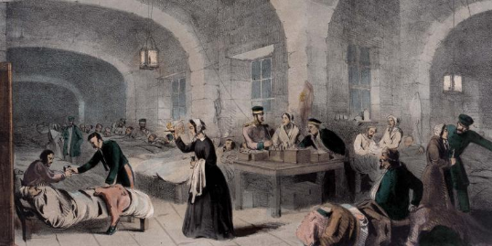
Nurses today


Look at the picture above. Describe the similarities and differences between now and during Florence’s time.

Similarities | Differences


What job would you like to do when you grow up and why?
Research a job and find out what important things they do in their job.

____________________________________________________________________________________________________________________________________________________________________________________________________________________________________________________________________________________________________________________________________________________________________________________________________________________________________________________________________________________

