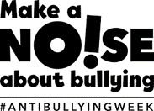

Anti-Bullying Week 2019 is taking place from Monday 11th – Friday 15th November and has the theme ‘Change Starts With Us’.
To recognise Anti-Bullying week, we would like you to create a comic strip type poster encouraging children to be good friends to each other in the classroom and playground.
Please think about: a situation, a problem and a solution. For example, a new child in a playground with nobody to play with day after day and how they can be helped.


