Year 6- science project
Animals including Humans
Due: 20/04/20
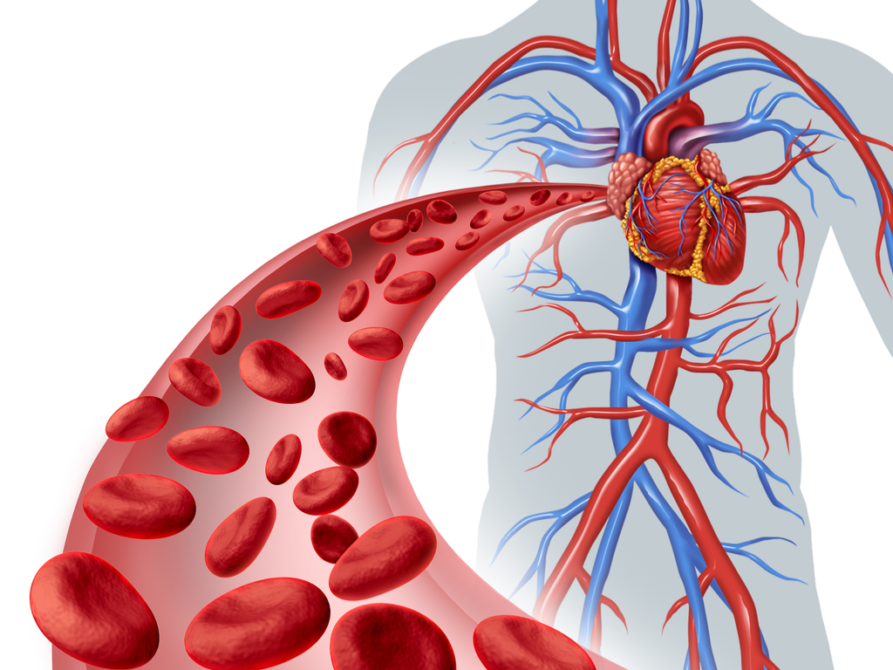
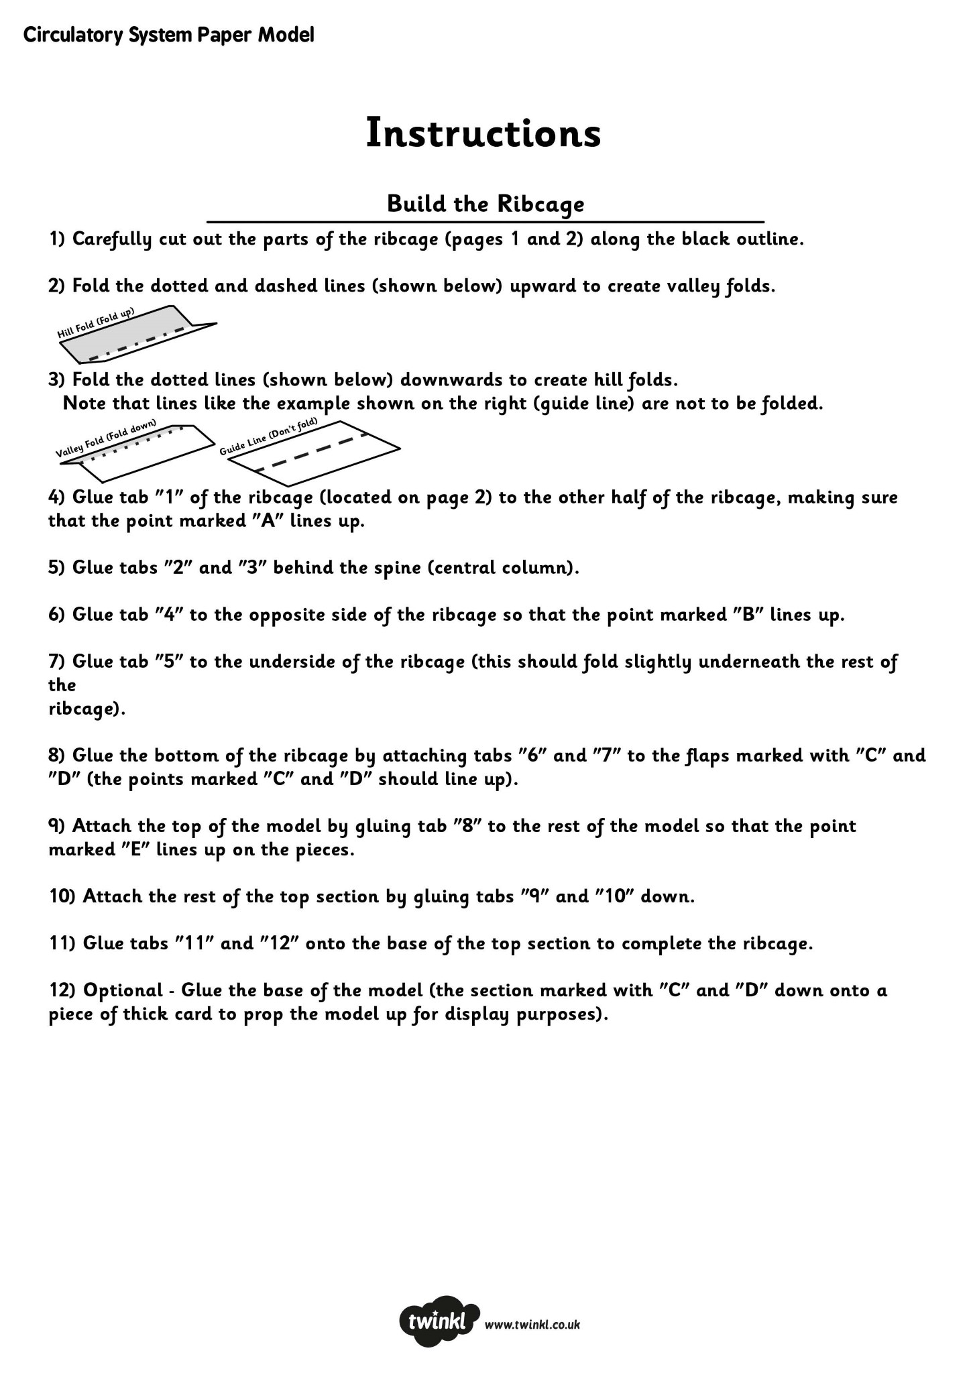
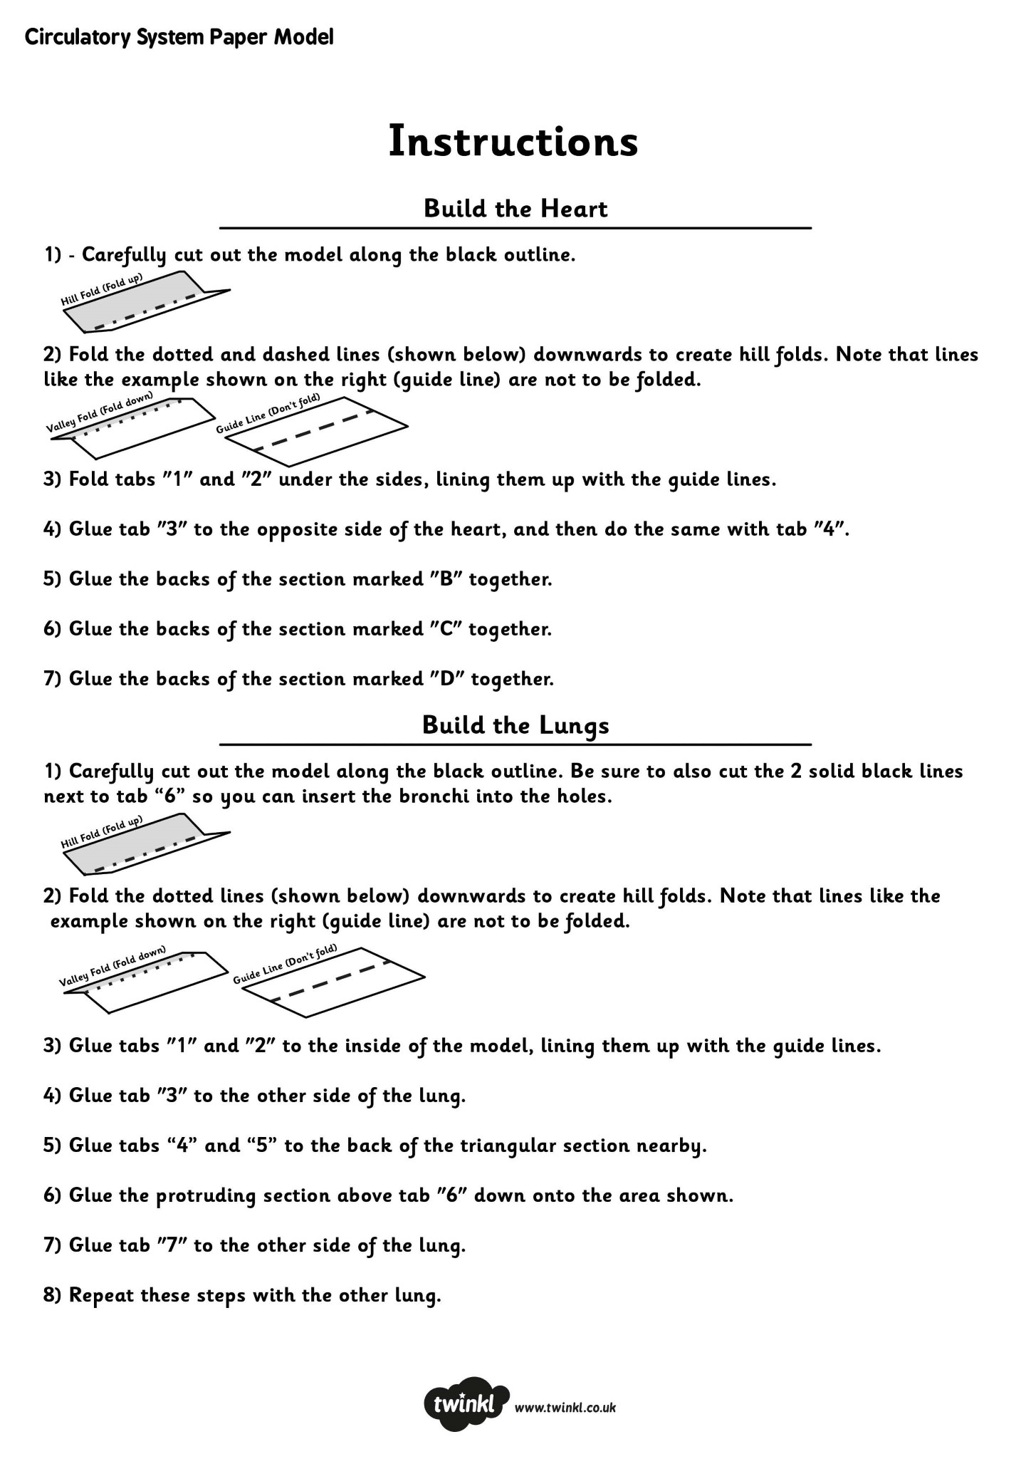
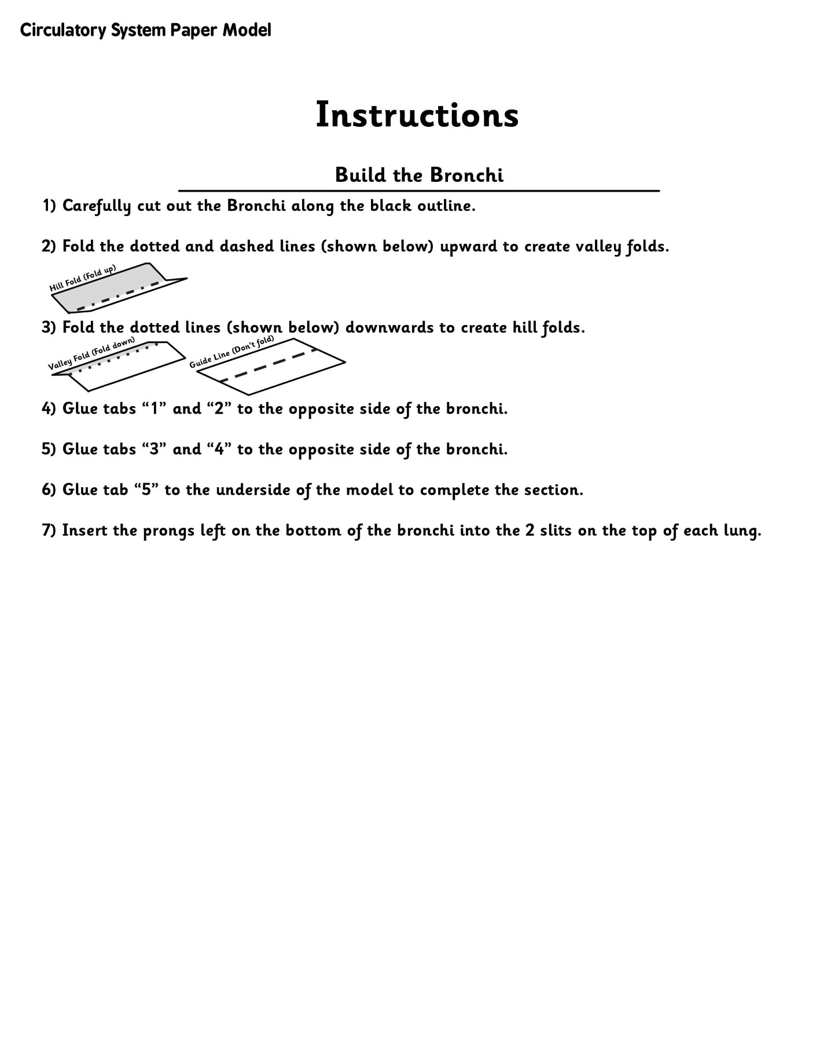

In the Summer term, our topic will be ‘Animals including Humans’. It’s a fascinating topic, which also plays a significant role in our everyday lives.

Compulsory challenge: Research the topic ‘Animals including Humans’ and conduct one of the following tasks:
- Create your own model of the Circulatory system or the Respiratory system. (There are many experiments and ideas online).
- Create a fact file on ‘Animals including Humans’ (ensure that you have thoroughly researched this topic)
- Create a poster to inform people about the function of the Circulatory/Respiratory system
- Create a leaflet about ‘Animals including Humans’ (ensure that you have thoroughly researched this topic)
- Essay style report on how the Coronavirus impacts the Respiratory system and the function of the Respiratory system.

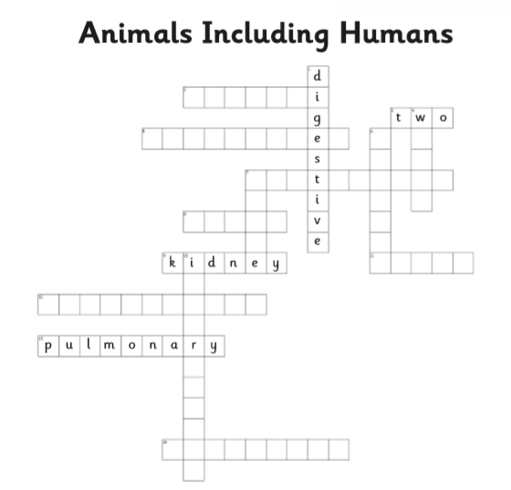
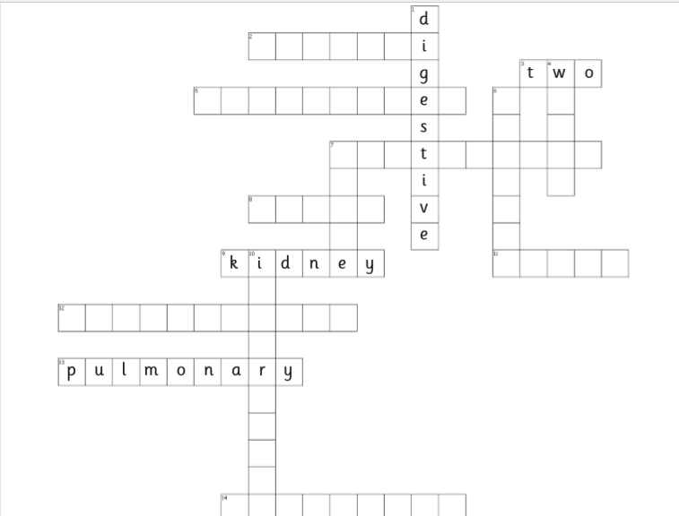
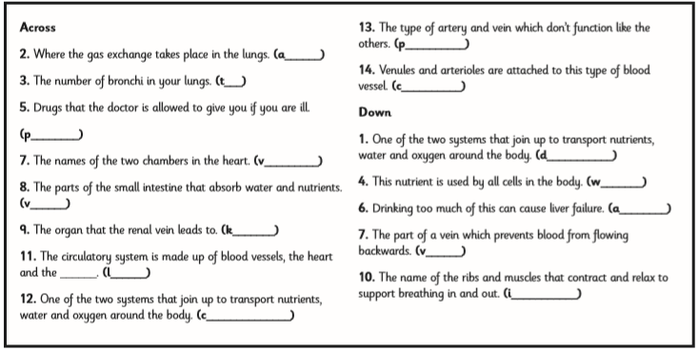
I

