SCIENCE HOMEWORK
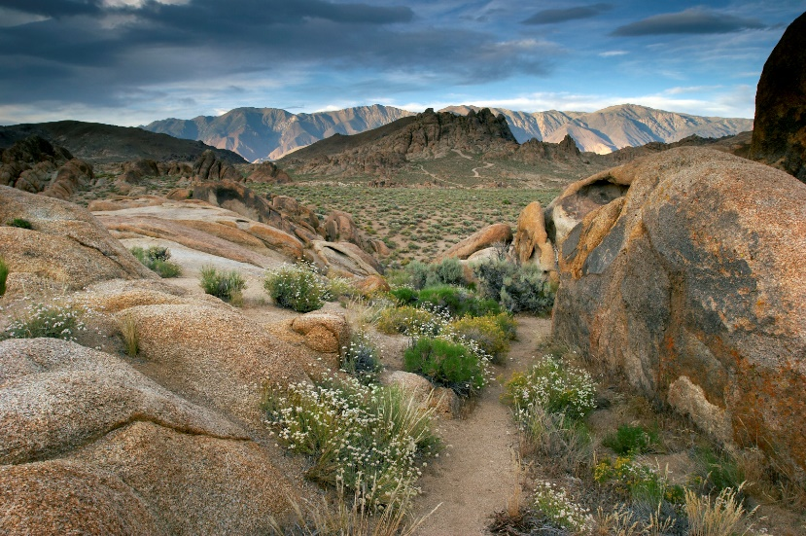
Your task this week is to research and create a report about this desert habitat. We learnt about different types of habitats and the types of plants and animals that would live in these habitats during the Autumn Term.
Your report should include the following:
- Countries in the world where this type of desert habitat could be found.

- The largest desert habitat in the world and the continent in which it is located (we looked at continents in Geography).

- At least 3 animals that would live in this type of habitat and how they have adapted to survive in this environment.

- At least 3 plants that would live in this type of habitat and how they have adapted to survive in this environment.

- one other type of habitat you have learnt about e.g. forest or arctic, its features and the types of plants and animals that would be found there.

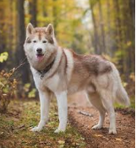
Challenge

What adaptations would this Siberian Husky need to make in order to survive in the desert habitat? Why?

